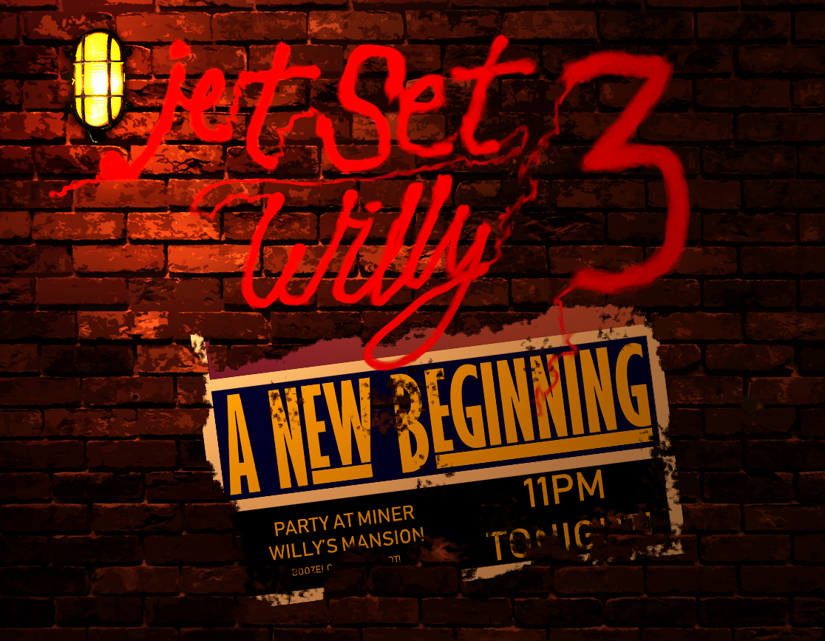

Design Document for:

Jet Set Willy 3: A New Beginning

All work Copyright ©2018 by Reboot Games

Written by Luke Bruni

Version # 2.00

Jet Set Willy 3: A New Beginning 1
Revisions 4
Game Overview 5
Philosophy 5
Revival 5
PC and beyond… 5
Common Questions 5
What is the game? 5
Why create this game? 5
Where does the game take place? 5
What do I control? 5
How many characters do I control? 5
What is the main focus? 5
What’s different? 6
What’s in a Game 7
Gameplay Overview 7
Money 7
Punch Ups 7
Platforming 7
Controls 8
The Mansion 9
Overview 9
Non-linear 9
What’s in the mansion? 9
Overview 9
Key Locations 9
Scale 9
Game Engine 10
Overview 10
Game Engine Detail #1 10
Water 10
Collision Detection 10
Game Characters 11
Main/Playable Characters 11
Miner Willy 11
Andre the Chef 11
Enemies and Monsters 11
User Interface 12
Overview 12
HUD 12
Musical Scores and Sound Effects 13
Overview 13
Red Book Audio 13
3D Sound 13
Sound Design 13
Single-Player Game 14
Overview 14
Single Player Game Detail #1 14
Single Player Game Detail #2 14
Story 14
Hours of Gameplay 14
Victory Conditions 14
Multiplayer Game 15
Overview 15
Max Players 15
Servers 15
Customization 15
Internet 15
Gaming Sites 15
Persistence 15
Saving and Loading 15
Extra Miscellaneous Stuff 16
Overview 16
Junk I am working on… 16
“XYZ Appendix” 17
“Objects Appendix” 17
“User Interface Appendix” 17
“Networking Appendix” 17
“Character Rendering and Animation Appendix” 17
“Story Appendix” 17

Revisions

Version | Name | Date | Notes
1.01 | Luke Bruni | 20/12/2017 | Initial Document
2.00 | Luke Bruni | 07/11/2026 | Complete Rewrite

Game Overview

Philosophy

Revival

The game is trying to capture the original essence of the Jet Set Willy and Manic Minor games and hopefully bring the series back to full form towards a more modern audience.

PC and beyond…

The series were developed for a variety of PCs at the time, which unfortunately such platforms doesn’t exist anymore, where the operating system is the same and the variety comes from the user designing their own dream PC. The aim is to design the game for PC and broaden the horizon of the game towards more platforms, such as Xbox One, PS4, etc.

Common Questions

What is the game?

The game is a sequel to that of the 2nd Jet Set Willy game (Not counting the Perils of Willy). A platformer that aims to take the original and build upon it for the modern audience, while reaching out towards the older fans of the game.

Why create this game?

As well as develop for the Reboot Games site, the aim is to bring back one of Britain’s old gaming icon of the 80s, bring him to a more modern audience and make a game that would improve upon the formula of the older games.

Where does the game take place?

The game takes place in his larger-than-life, bizarre mansion that is made of his wildest dreams. The player can explore it all with no locked areas, straight from the get-go.

What do I control?

The player controls Miner Willy, a playboy and self-retired miner. The player can traverse the mansion, such as a traditional platformer and the older games of the series, however the player can now fight but only when within certain situations.

How many characters do I control?

The player can not only control Willy, but also some other characters, such as the mansion’s chef Andre and the maid Maria, to name a few. The characters are unique in terms of animation but don’t have any special abilities. These characters are unlocked over the course of the game.

What is the main focus?

The game is about Willy, having a visit from the Taxman after a wild party. The taxman has had enough of Willy skimping payments and has threatened to end his riches if Willy doesn’t pay all his remaining taxes.

What’s different?

Unlike more common platformers, it’s bringing back the non-linear style that was present within the old games. A style more prominent in games such as Bioshock, a first-person shooter, and numerous RPGs.

In comparison with this game and the older games, the platforming is revamped to reflect on much quicker gameplay and to keep up with the quicker gameplay seen in most games today, deviating on the slower gameplay of the original games.

What’s in a Game

Gameplay Overview

The gameplay will match the original nonlinear style of the game where the player can explore all his mansion at will and take different approaches to getting to the goal. To help with the exploration, the game is not divided into “rooms” (The game's not “flip-screen”).

The game takes the same approach to collecting items, but rather than the item negating from a counter the amount of money found inside that item or the value of that item will add to the money counter. The money takes on many forms, like stated before, money can be picked up inside objects in the house or found in various places. Money is more the aim here and Willy must collect enough money to fulfil a quota. This quota will change and the game will change along with it, altering some of the levels. Quotas will keep being fulfilled to progress the game's story until the end

Money

A notable change in the objective will be what is needed to complete the game. Money is now the aim of the game instead of collecting items in the older games and is needed to fulfil the quota of the taxman.

Money can be found around the mansion, either in obvious places, items, cabinets or in specific areas. The money in the game can have various amounts depending on where the money is found, for instance:

- Found areas: £50 - £200
- In cabinets, dressers, closets, etc.: £1000 – £5000
- In items: At least £800

Specific areas trigger events to which the player can complete to earn a good pay-out from them (At least £10,000). However, the player could be met with consequences to which they would need to avoid them.

Once Willy has met an objective amount, newer events will happen such as newer stuff getting added or the game will begin to get harder. This will continue until the end of the game.

Punch Ups
Willy can now fight, throw punches and knock enemies out. Sure, blood may be spilled along the way, but the combat won't be a staple in the mechanics (there won't be any weapons as well), being that the game focuses in the platforming, where fighting will be as a last resort or saved as part of a certain mission.

Platforming
His platforming ability has improved immensely; he can grab ledges, run, duck and roll, which should add some tense action to traversing the mansion.

The Mansion

Overview

The mansion is Willy’s prised home and the result of his mining success. The entire place along with Willy’s personal possessions are at risk of being repossessed by the taxman, so it is up to him to save everything before that happens.

The mansion is larger than life, but rather a small, quaint home to Willy. Contained within it are bizarre rooms and things; some dangerous and some unknown to Willy.

Non-linear

Following the non-linear style of the game and the games before it, the entire mansion can be explored at will, right from the get go and no areas that need to be unlocked. No catches, no items required to enter a room, just the freedom to roam about and explore the mansion as much as we can at any time.

What’s in the mansion?

Overview

The mansion is built up of various rooms that the player can take many routes to get to. They all consist of platforms of various size and properties, much like the game’s precursors.

As the game goes on, the rooms may change along the way depending on the playthrough; there could be a new enemy that appears in the rooms or an entire room may be blown to bits for reasons of plot (or not!).

Key Locations

- Banyan Tree – The original tree all in its glory, a pain to get through on the original game, but will now be redesigned to be easier to get through.
- MegaTree – The tree in the front yard of the mansion, where Willy can explore for money and then can head off to the off-license if he gets bored. This area will be larger for the player to explore and to add more challenge. In homage to the unfinished third game in the Miner Willy series.
- Entrance to Hades – This time it WILL be Hell!

Scale

The world will be large, larger than the original games and newer areas will be added along with the original ones.

The room names will come up to show the user where they are, which should help navigation.
If the user is REALLY lost, then a map can be used to find out where the user is, which will be in the style of floor plans/blueprints.

Game Engine

Overview

The engine used to create the game will be in Unity. Unity was chosen because it has very good 2D compatibility and good, recent knowledge of the engine. Other features of this engine below.

Sprite Management

Working with sprites in unity are easy to work with. Sprites can be assigned various properties for various features such as animation and multiple sprite sheets. A sprite editor can be used for use of sprite slicing for animations or menus.

Animation

Unity has numerous features for managing animation. The engine has two methods of animations; frame by frame and through a curve editor, but for 2D animation, frame by frame is necessary. The engine uses both animation controllers for individual actions and a timeline for cinematics, which use the animation files from the animator mentioned earlier.

Game Characters

Main/Playable Characters

These characters can be unlocked over the course of the game and can be switched out during gameplay. These playable characters can be used in the multiplayer aspect of the game.

Miner Willy

The player takes control of the main character, Miner Willy. A semi-retired miner and playboy, owner of a large mansion filled with bizarre things and generally where he spends all his life in.

Andre the Chef

The mansion’s chef. Mostly laid back, hardly works because of poor pay checks, going mostly to Willy. Gets involved in Willy’s debt at one point.

Maria

The mansion’s housekeeper, always tired with Willy’s antics, ultimately rules the mansion with an iron fist, or so she thinks

Brother Geoff

Overly religious pastor that runs the chapel inside Willy’s mansion. Claims to be a man of the lord but manages to open a portal to Hell.

Brian

Willy’s annoying friend that manages the off license located nearby, just after the MegaTree. There mainly to “help” Willy and has a pint with him most of the time.

Enemies and Monsters

The enemies in Jet Set Willy 3 are far random, dependant on the room that willy could go in or some that just come up from time to time. The main enemies that Willy will encounter alongside these enemies and static hazards:

- Repo Men
- Party Goers
- The Taxman himself!
- And many more!

The Taxman

The man that people hate. An overbearing, obnoxious person that would only think of himself. Slick hair and a long overcoat and would do anything to get money from people. Often, he would go into a fit of insanity and would beat people up, should they cross him.

He comes prepared with a unit; heavy repo men that would come to trash the place to collect money or valuable objects to pay off a debt if the person doesn’t pay. These people can’t be knocked down and Willy would need to avoid them most of the time, though he can stun them for a bit.
User Interface

Overview

As the game is mainly derived from its prequels, the interface should be simple enough for the user and not be needlessly complicated at all. Menus are simple, being there will be some options to configure and something for the extra features; a basic main menu system with some extra aesthetics that match the design of the game.

HUD

Regarding the UI for the initial game, it will function similarly to that of the original games. i.e. the location names and objectives (items collected in the old games, money in this sequel). The HUD will be updated and designed to allow for the game to be centre stage and not take up a portion of the screen.

Control

Methods

Direct Control

Action | Key binding
Move Left | 'A'/Left Key
Move Right | 'D'/Right Key
Jump | 'W'/SPACE/Up Key
Duck | CTRL/Down Key
Roll | SHIFT
Punch | Left Mouse
Block | Right Mouse
Interact | 'E'
Pause | ESC

Single-Player Game

Story
Willy is back after a long relaxing break, but it's not the comeback he was expecting. After a huge party, a hungover Willy gets a visit from a nemesis: The Taxman! After skimping on his taxes and cashing out on necessities for himself, it turns out that the taxman is gonna get his sick dream of repossessing ol' Willy. Now, our hero must scrounge his own bizarre, party ridden mansion to find his money or the taxman will take all of what he has earned! – Official Summary
The story begins with Willy waking up from a dream of him in the old game style, which is the original ending for Jet Set Willy; heading for bed, but then heading into the bathroom and getting stuck in the toilet.

He gets a knock on the door and goes down to answer it, revealing the taxman, looking smug with himself with his henchmen close by. He explains to Willy, with a couple of jokes, that he has been skimping out on payments to him to which he only has a limited amount of time to gather over £25,000,000 to pay off, or “He’ll break your teeth in”.

A glum looking willy now must collect his amount each time or his place gets torched, but gets an idea to look throughout the whole of his mansion to find every little amount, regardless if it kills him or not.

Throughout his adventures Willy finds money in all locations until he is hit with a problem, that he still lacks it for a required amount. He then goes down to Andre in the kitchen, who tells him a party goer is keeping a required amount to which Willy must get the money back from. He heads up there to find Brian, drunk and violent, carrying the money. After a confrontation that gets Brian sober, he gives him the money to which he responds with “Whatever” and Willy gives the amount to the Taxman, who is contempt in Willy’s findings but then says to him that its only just begun…

Multiplayer Game

Overview

The multiplayer game aspect is a different version of the single player game, where the players take control of various characters and must collect money to a time limit. It’s more of a faster paced version where players must go separately or in groups to help collect money and survive the mansion.

The multiplayer section will be simple, with no levelling and such but with the choice of character that they can play. All the user has to do is make sure he/she has internet and they can just jump in and play!

Max Players

The game can have anywhere from 2 players up to 12 and local multiplayer can be used for online play as well.

Customization

The players can choose ANY character that is seen in the main game, this includes main characters, side characters and enemies. They don’t have unique abilities but have unique personalities that should add to the overall design experience.

Players can also chat in game to each other which comes up in a box but also a speech bubble if close by.

Internet

The servers will be Listen servers, which give benefits of what dedicated servers have but should allow for quicker games. However, because of the type of game this is for multiplayer, other investigations will commence.

